FALL LEAGUE SOFTBALL & TBALL SIGN UPS
July 1st through August 1st
Games begin August 25th

Download registration form @ acpark@ky.gov
Or Register online @ tshq.bluesombrero/acprd

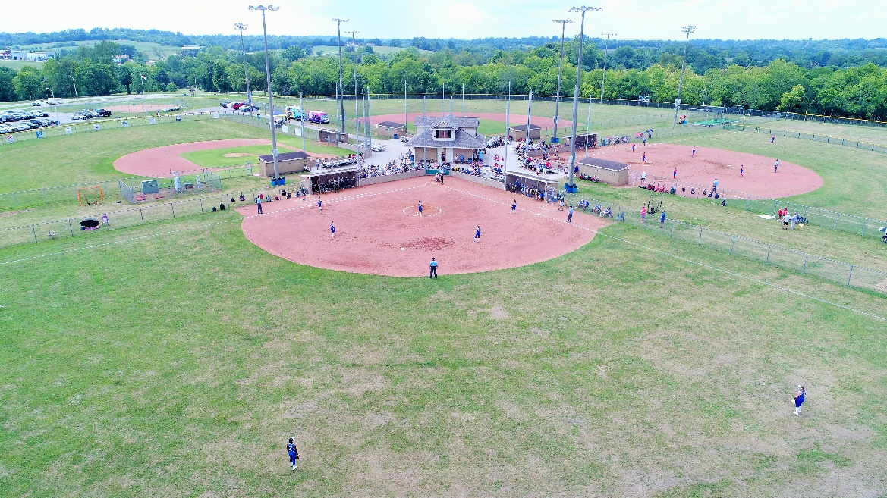

In person Sign Ups: July 9th 4PM – 8PM – Park Office
July 30th 4PM – 8PM – Park Office
August 4th 6PM Back to school bash at Park game fields.

